## Define 7+1 Data Types is JavaScript

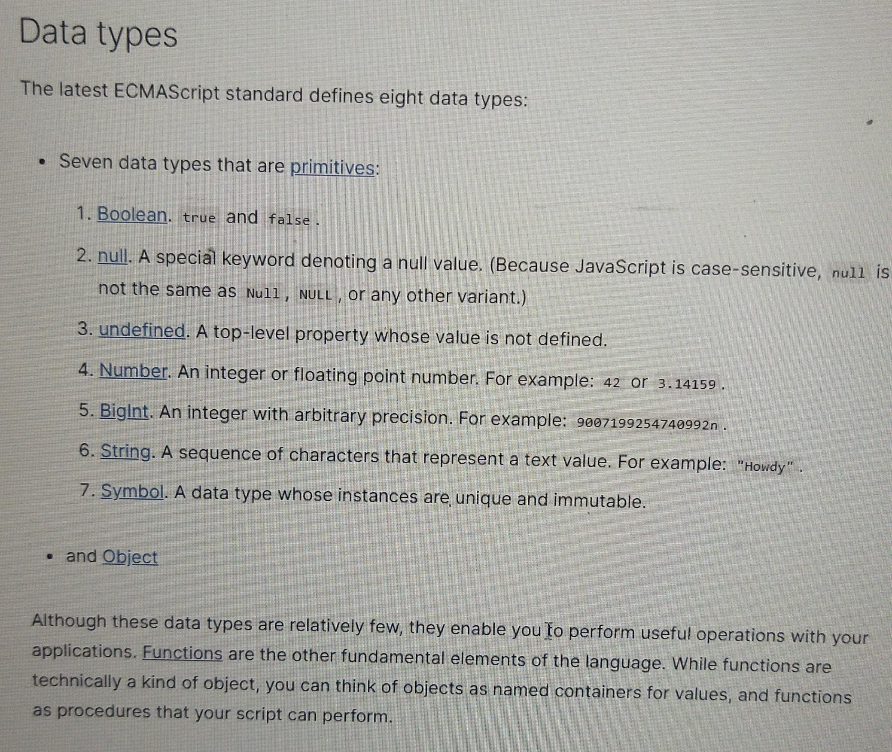

### Prototype or Inheritance

#### Define Inheritance concept

In programming inheritance refers to passing down characteristics from parent to a child so that new piece of code can reuse and build upon the features of an existing code.

#### Define Prototype or JavaScript inheritance

JavaScript implement inheritance by using objects.

Each object has an internal link to another object called its prototype

The prototype object has a prototype of its own, and so on until an object is reached with null as its prototype

By definition null has no prototype and acts as the final link in this prototype chain

It is possible to mutate any member of the prototype change or even swipe out the prototype at run time

The notation

someObject.[[Prototype] ]

or

someObject.__proto__

is used to designate the prototype of

someObject

The [[Prototype] ]  or myObj.__proto__

internal slot can be accessed and modified with

Object.getPrototypeOf()

and

Object.setPrototoyeOf()

respectively.

Note

Below gives synatax error

myObj.[[Prototype] ]

Both below prints prototype object of myObj

myObj.__proto__

Object.getPrototypeOf(myObj)

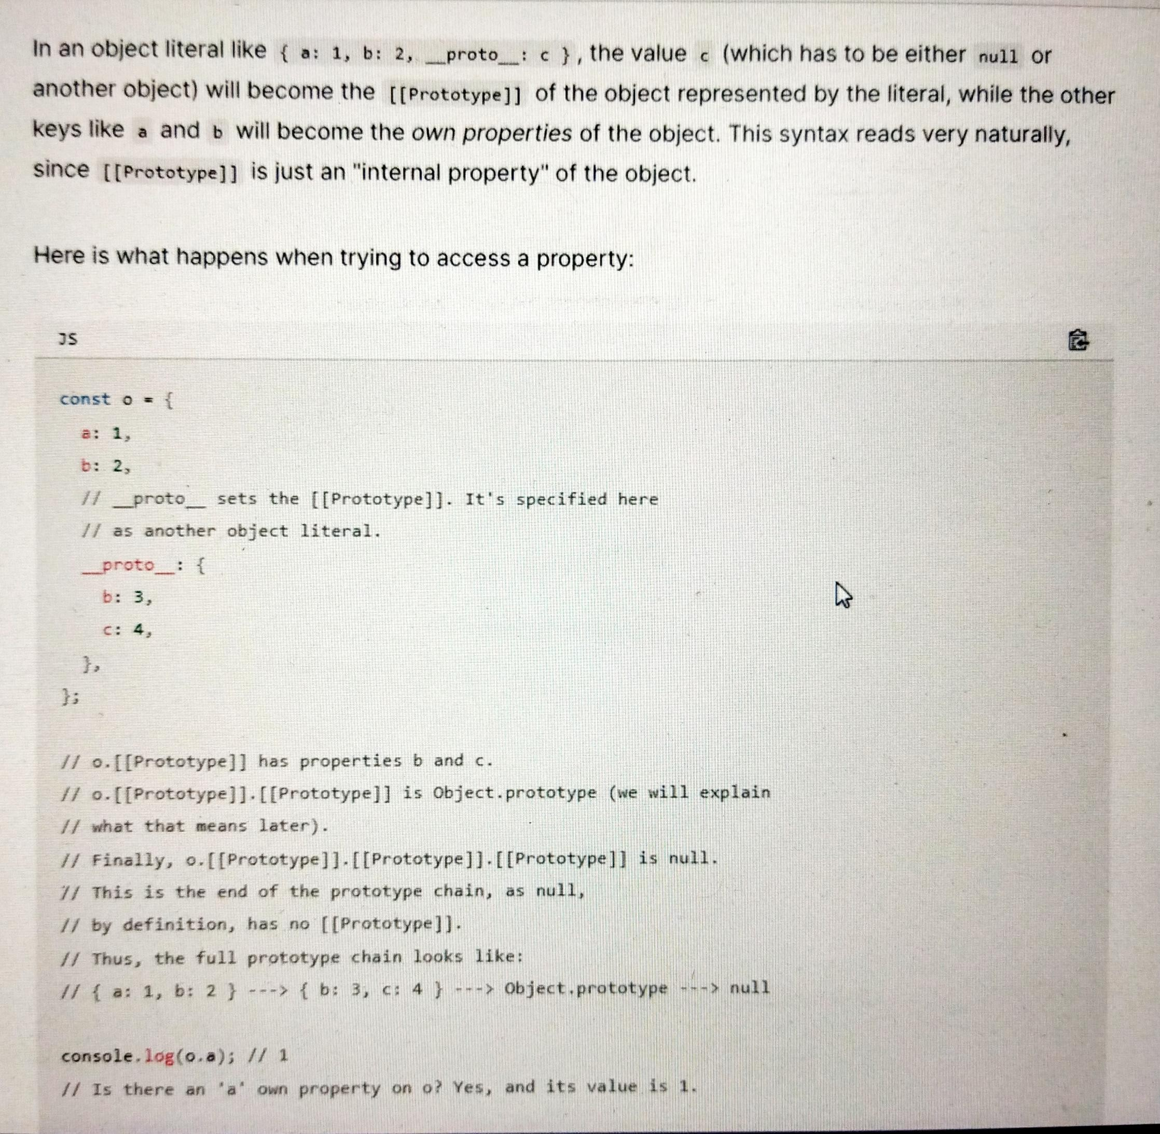

Explain Property shadowing ?

Refer below pic

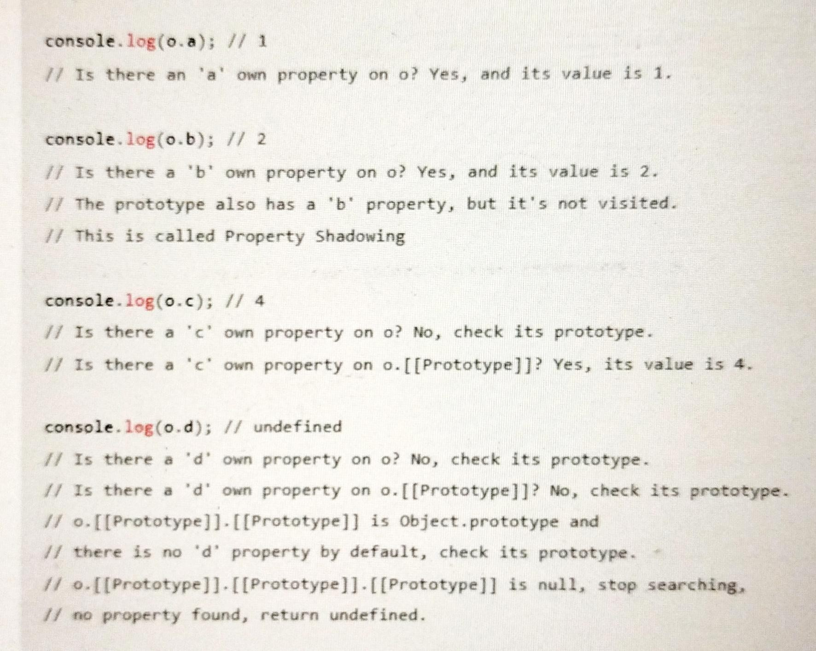

#### Define Property Shadowing / Method Overriding / Inheriting methods

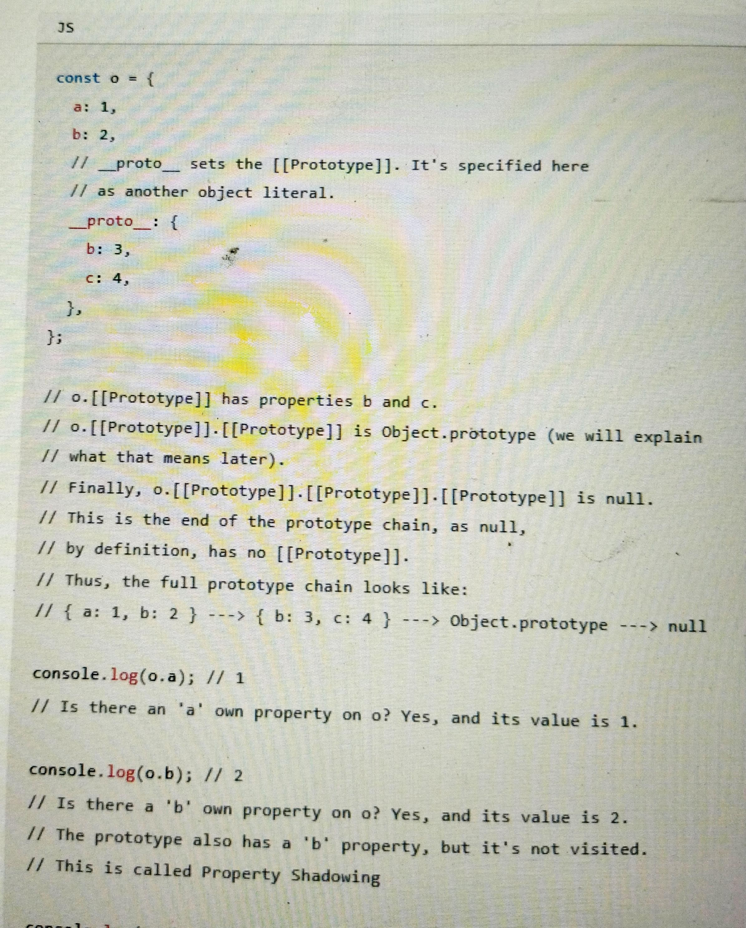

In JavaScript any function can be added to an object in the form of a property.

And inherited function acts just as any other property, including property shadowing as shown above, in this case a form of method overriding.

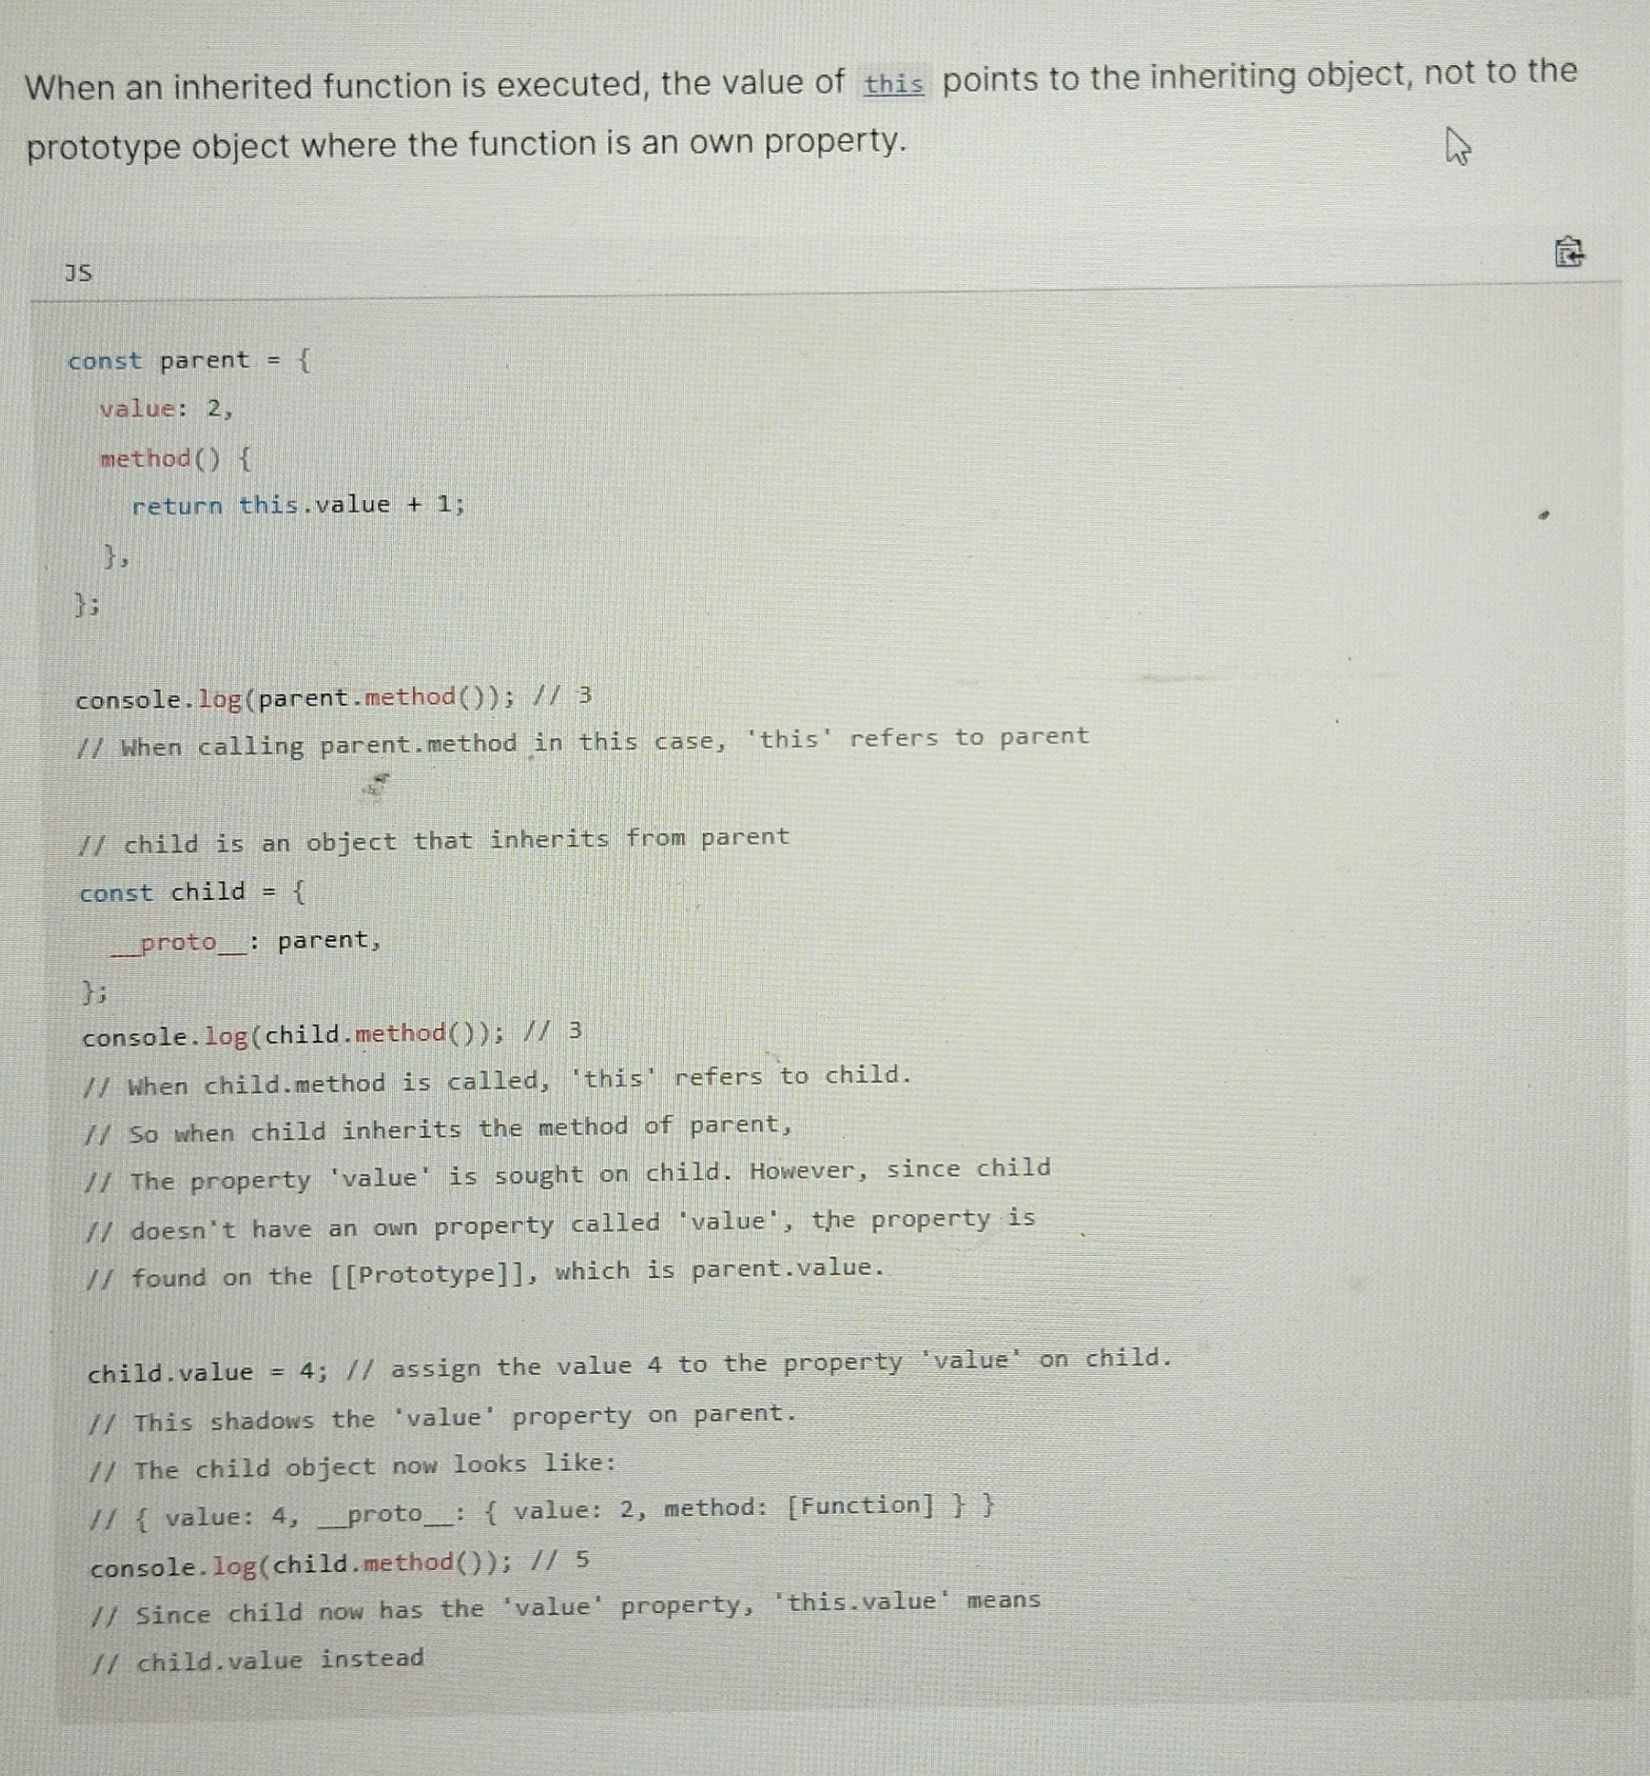

#### Practical example of Prototype

1. Construction function (not class based but function based)

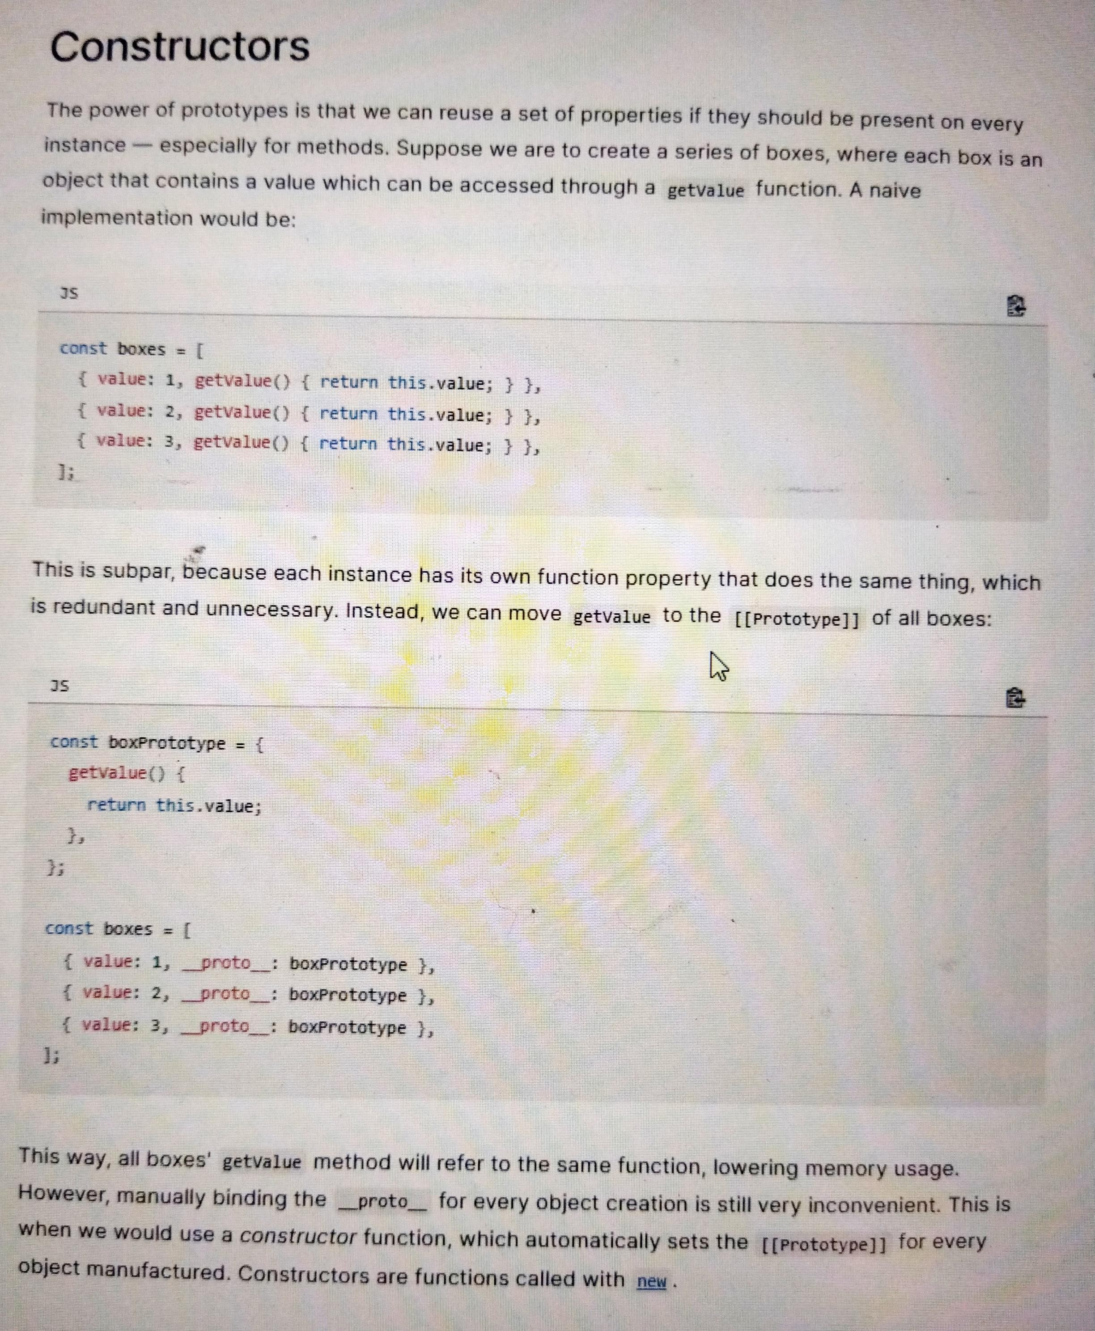

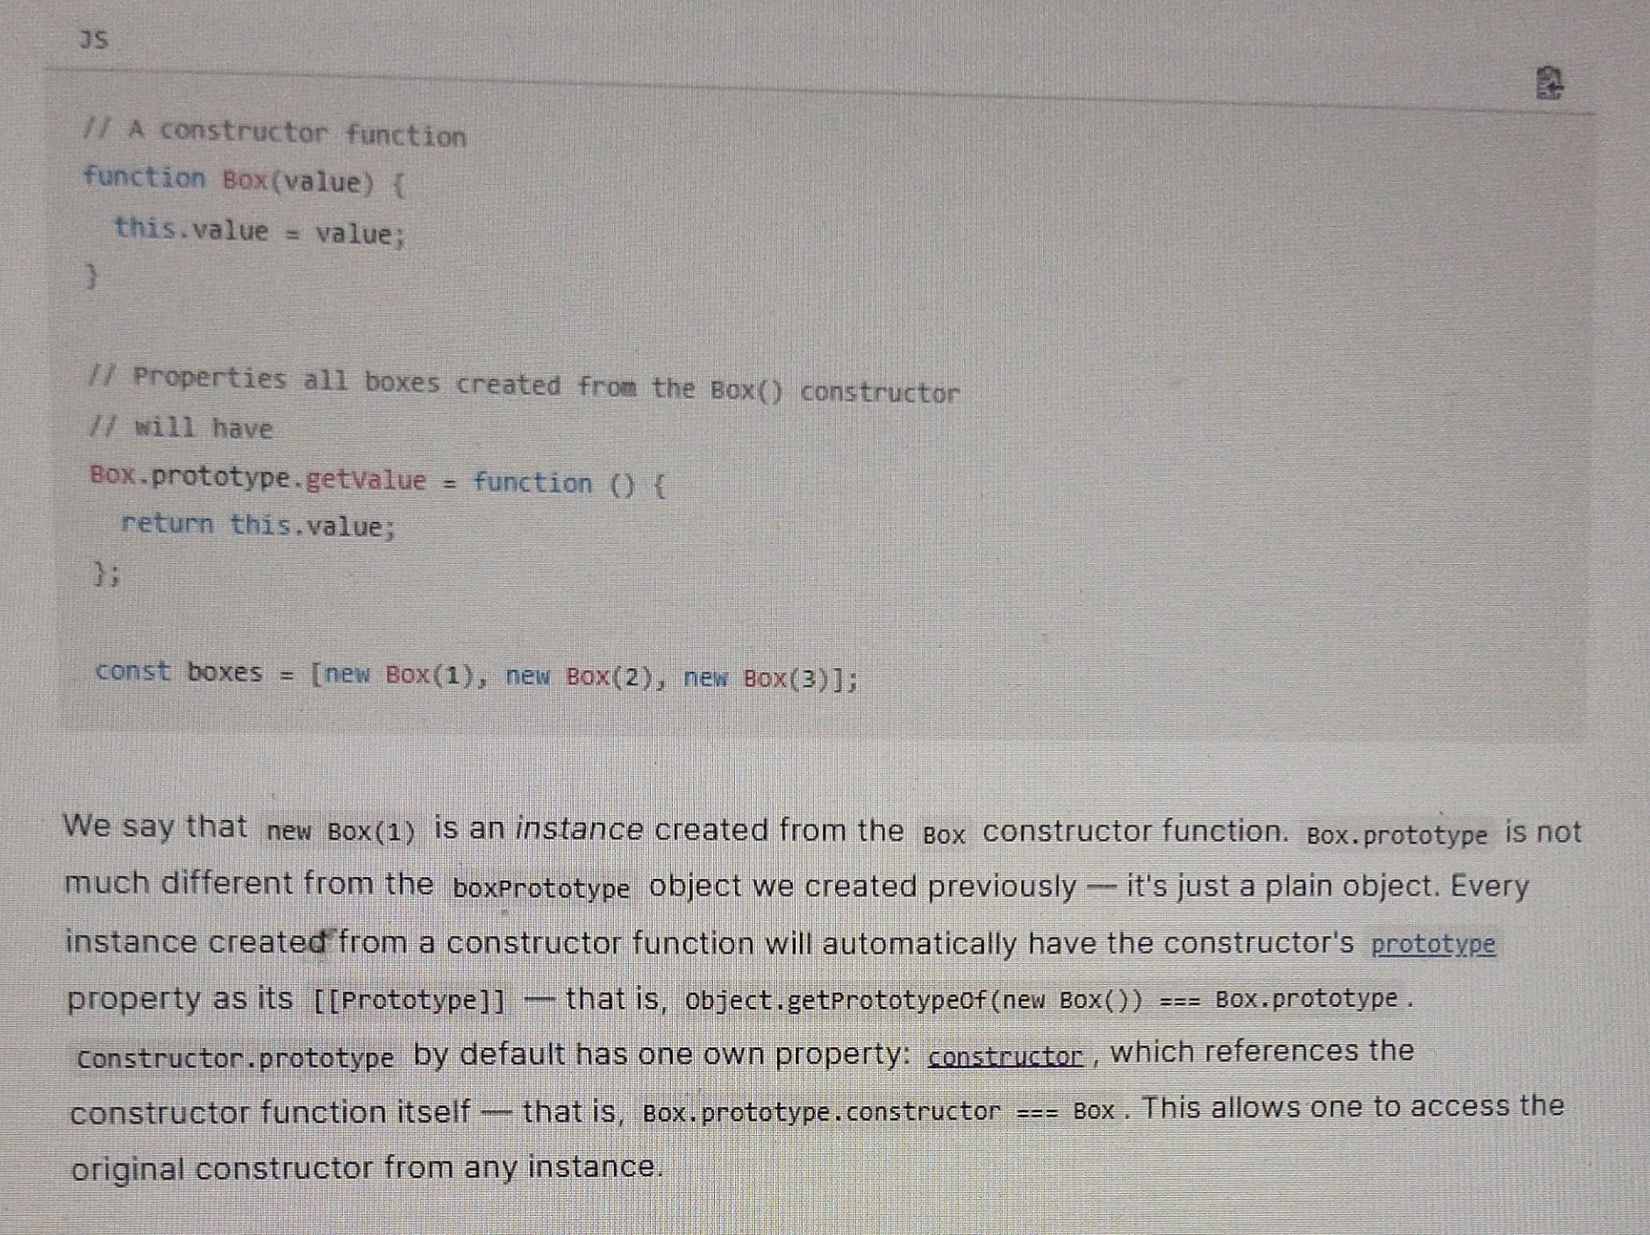

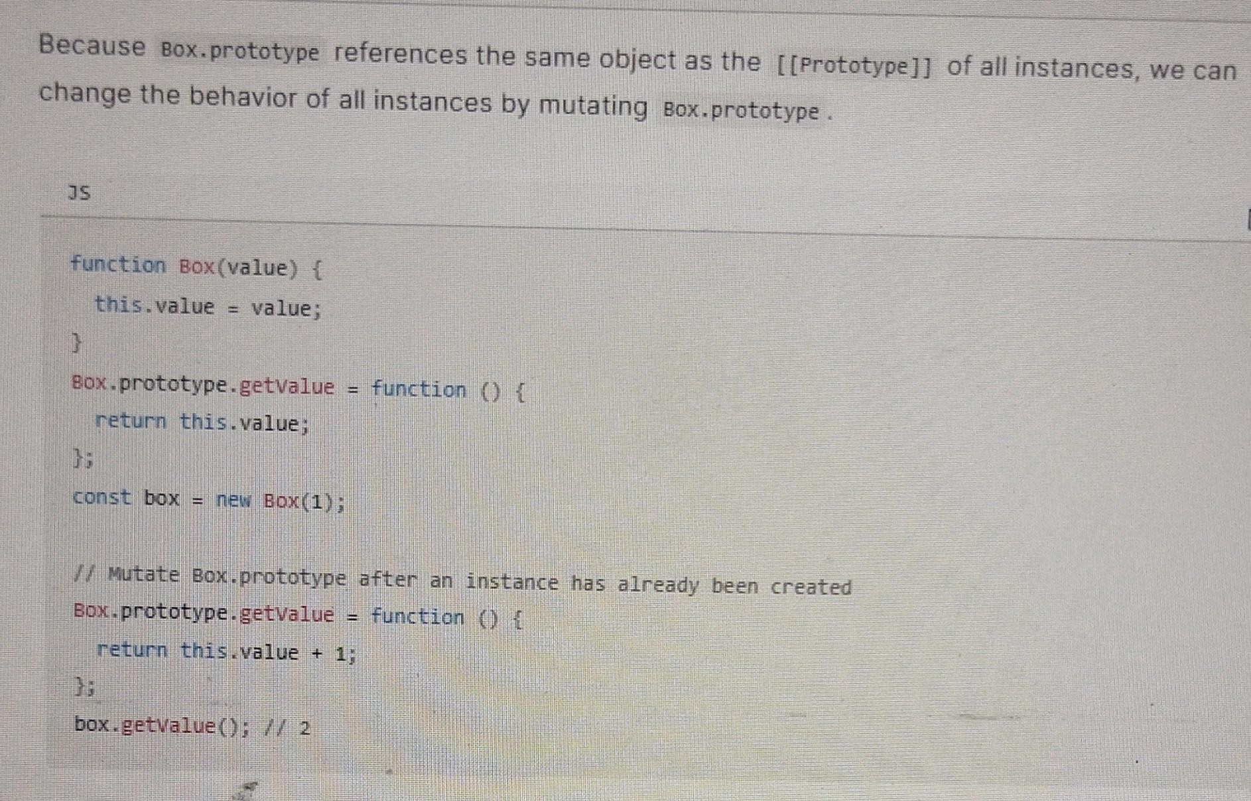

1. Code quiz for prototypes
2. 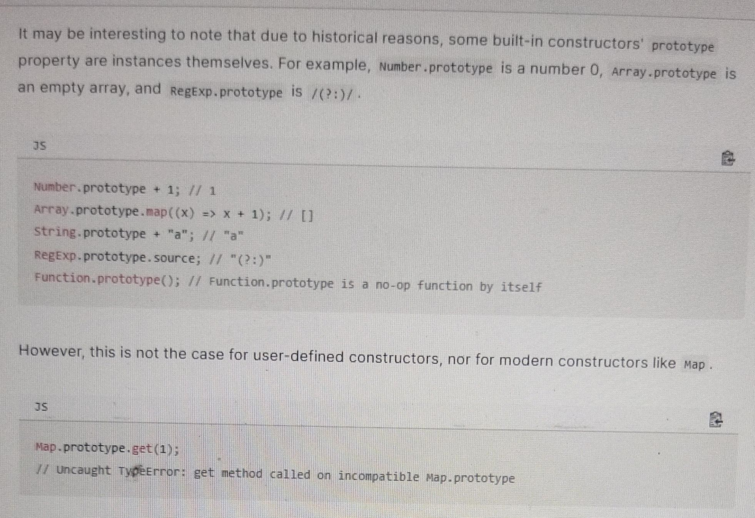

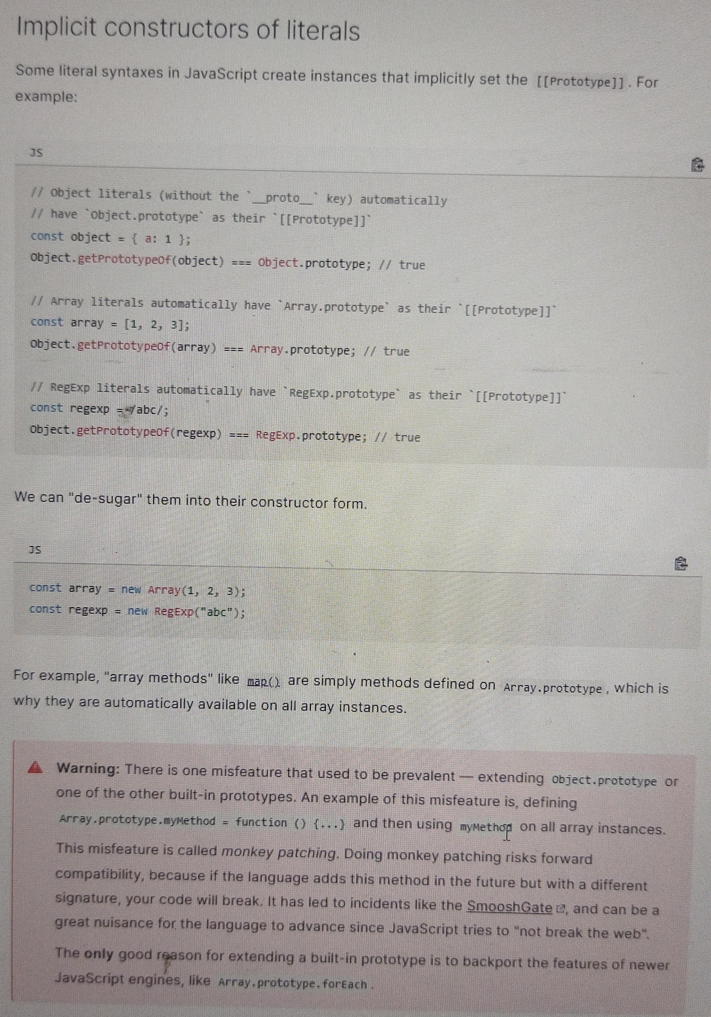

#### Playing with prototype chains

Different ways of creating and mutating prototype chains

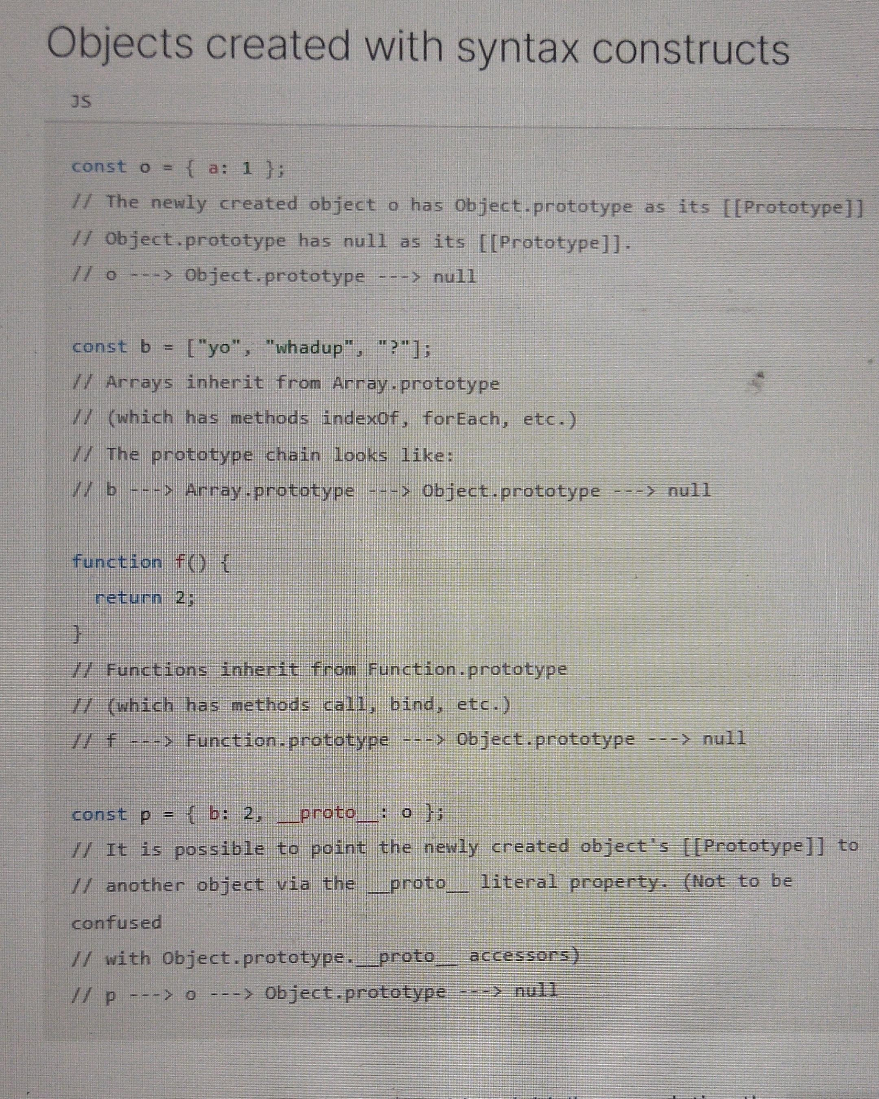

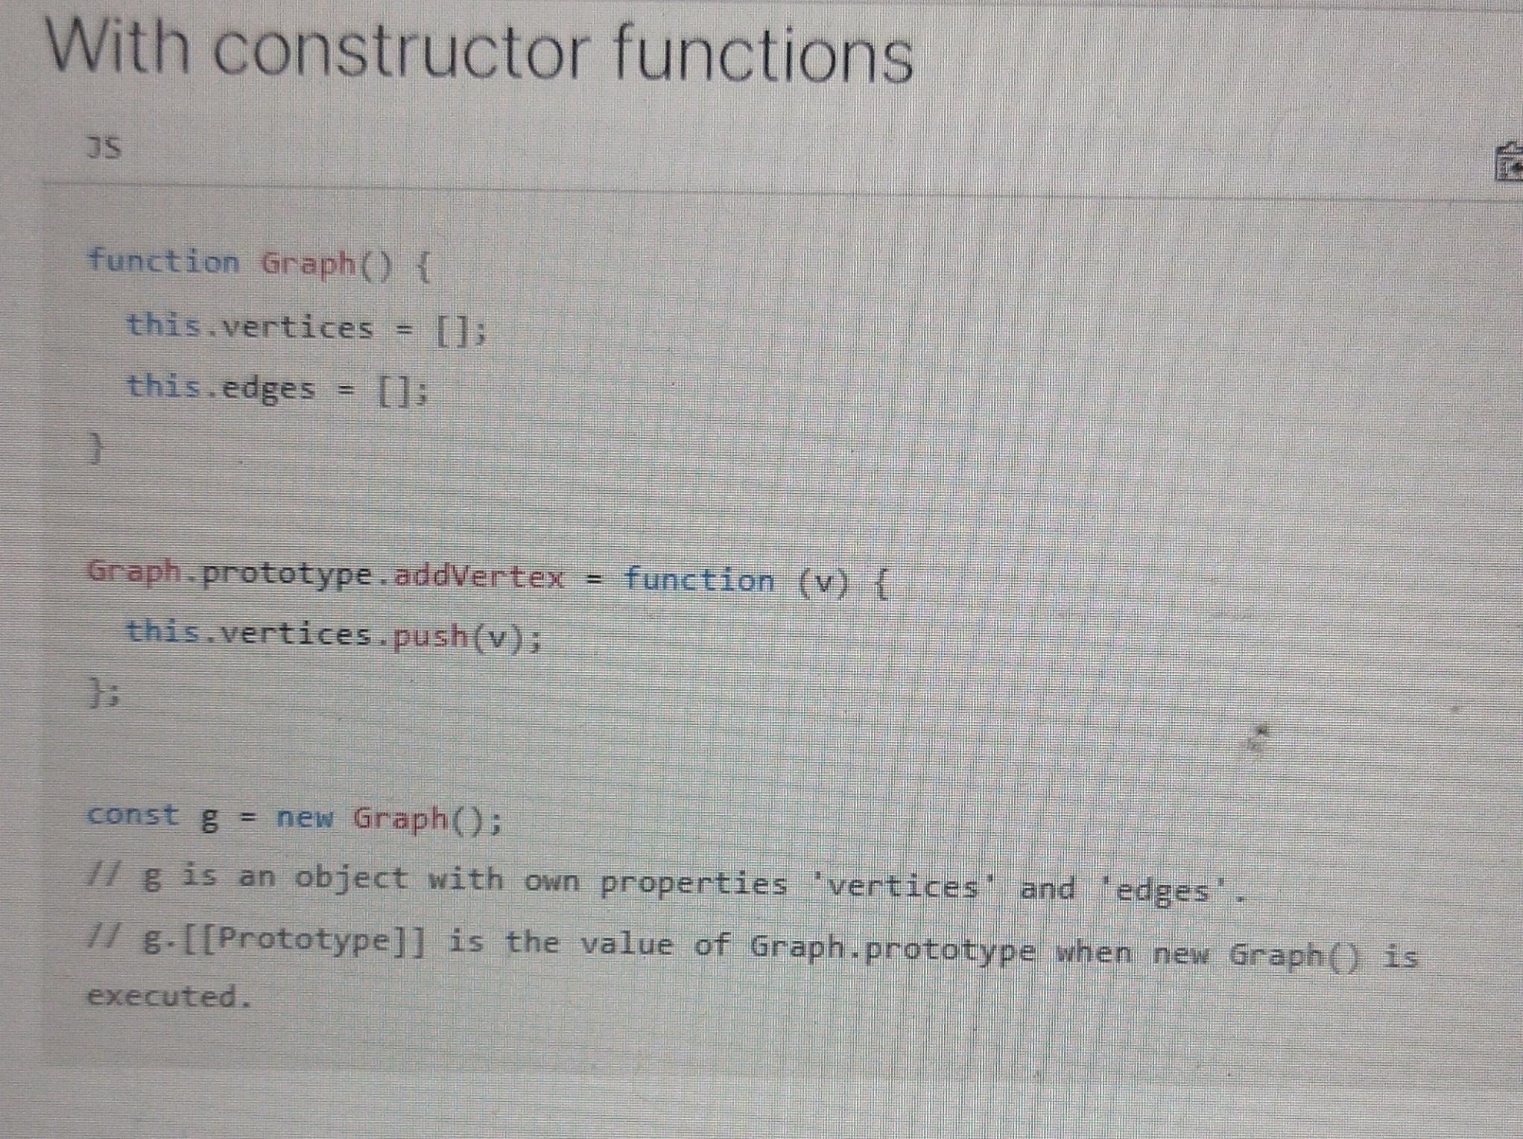

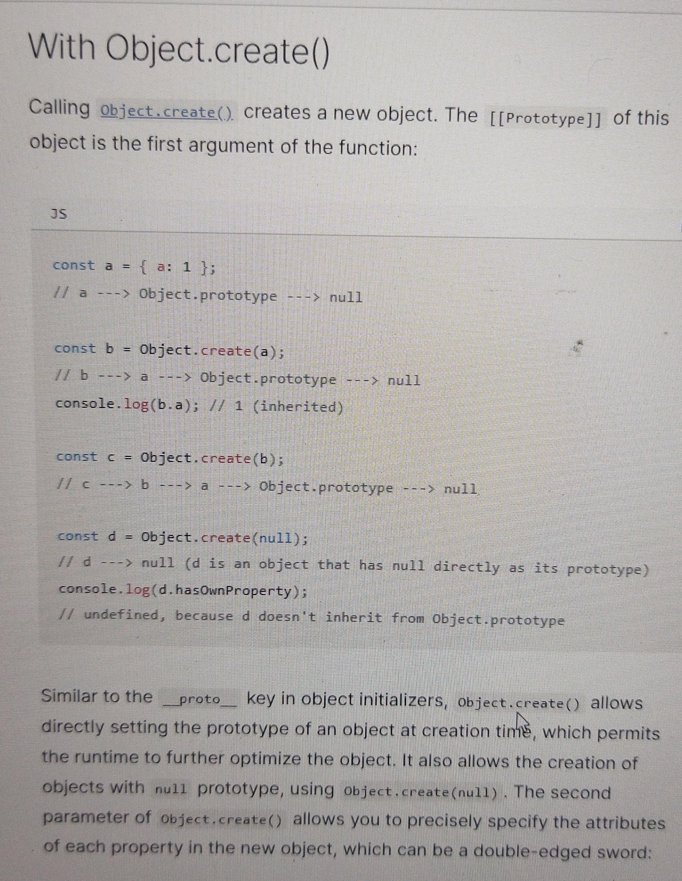

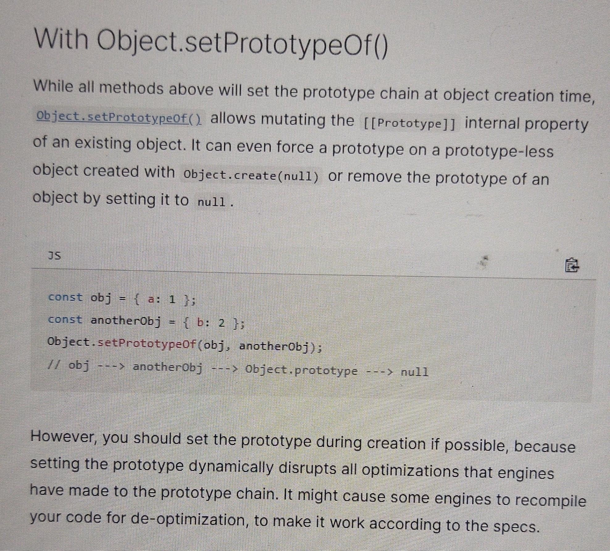

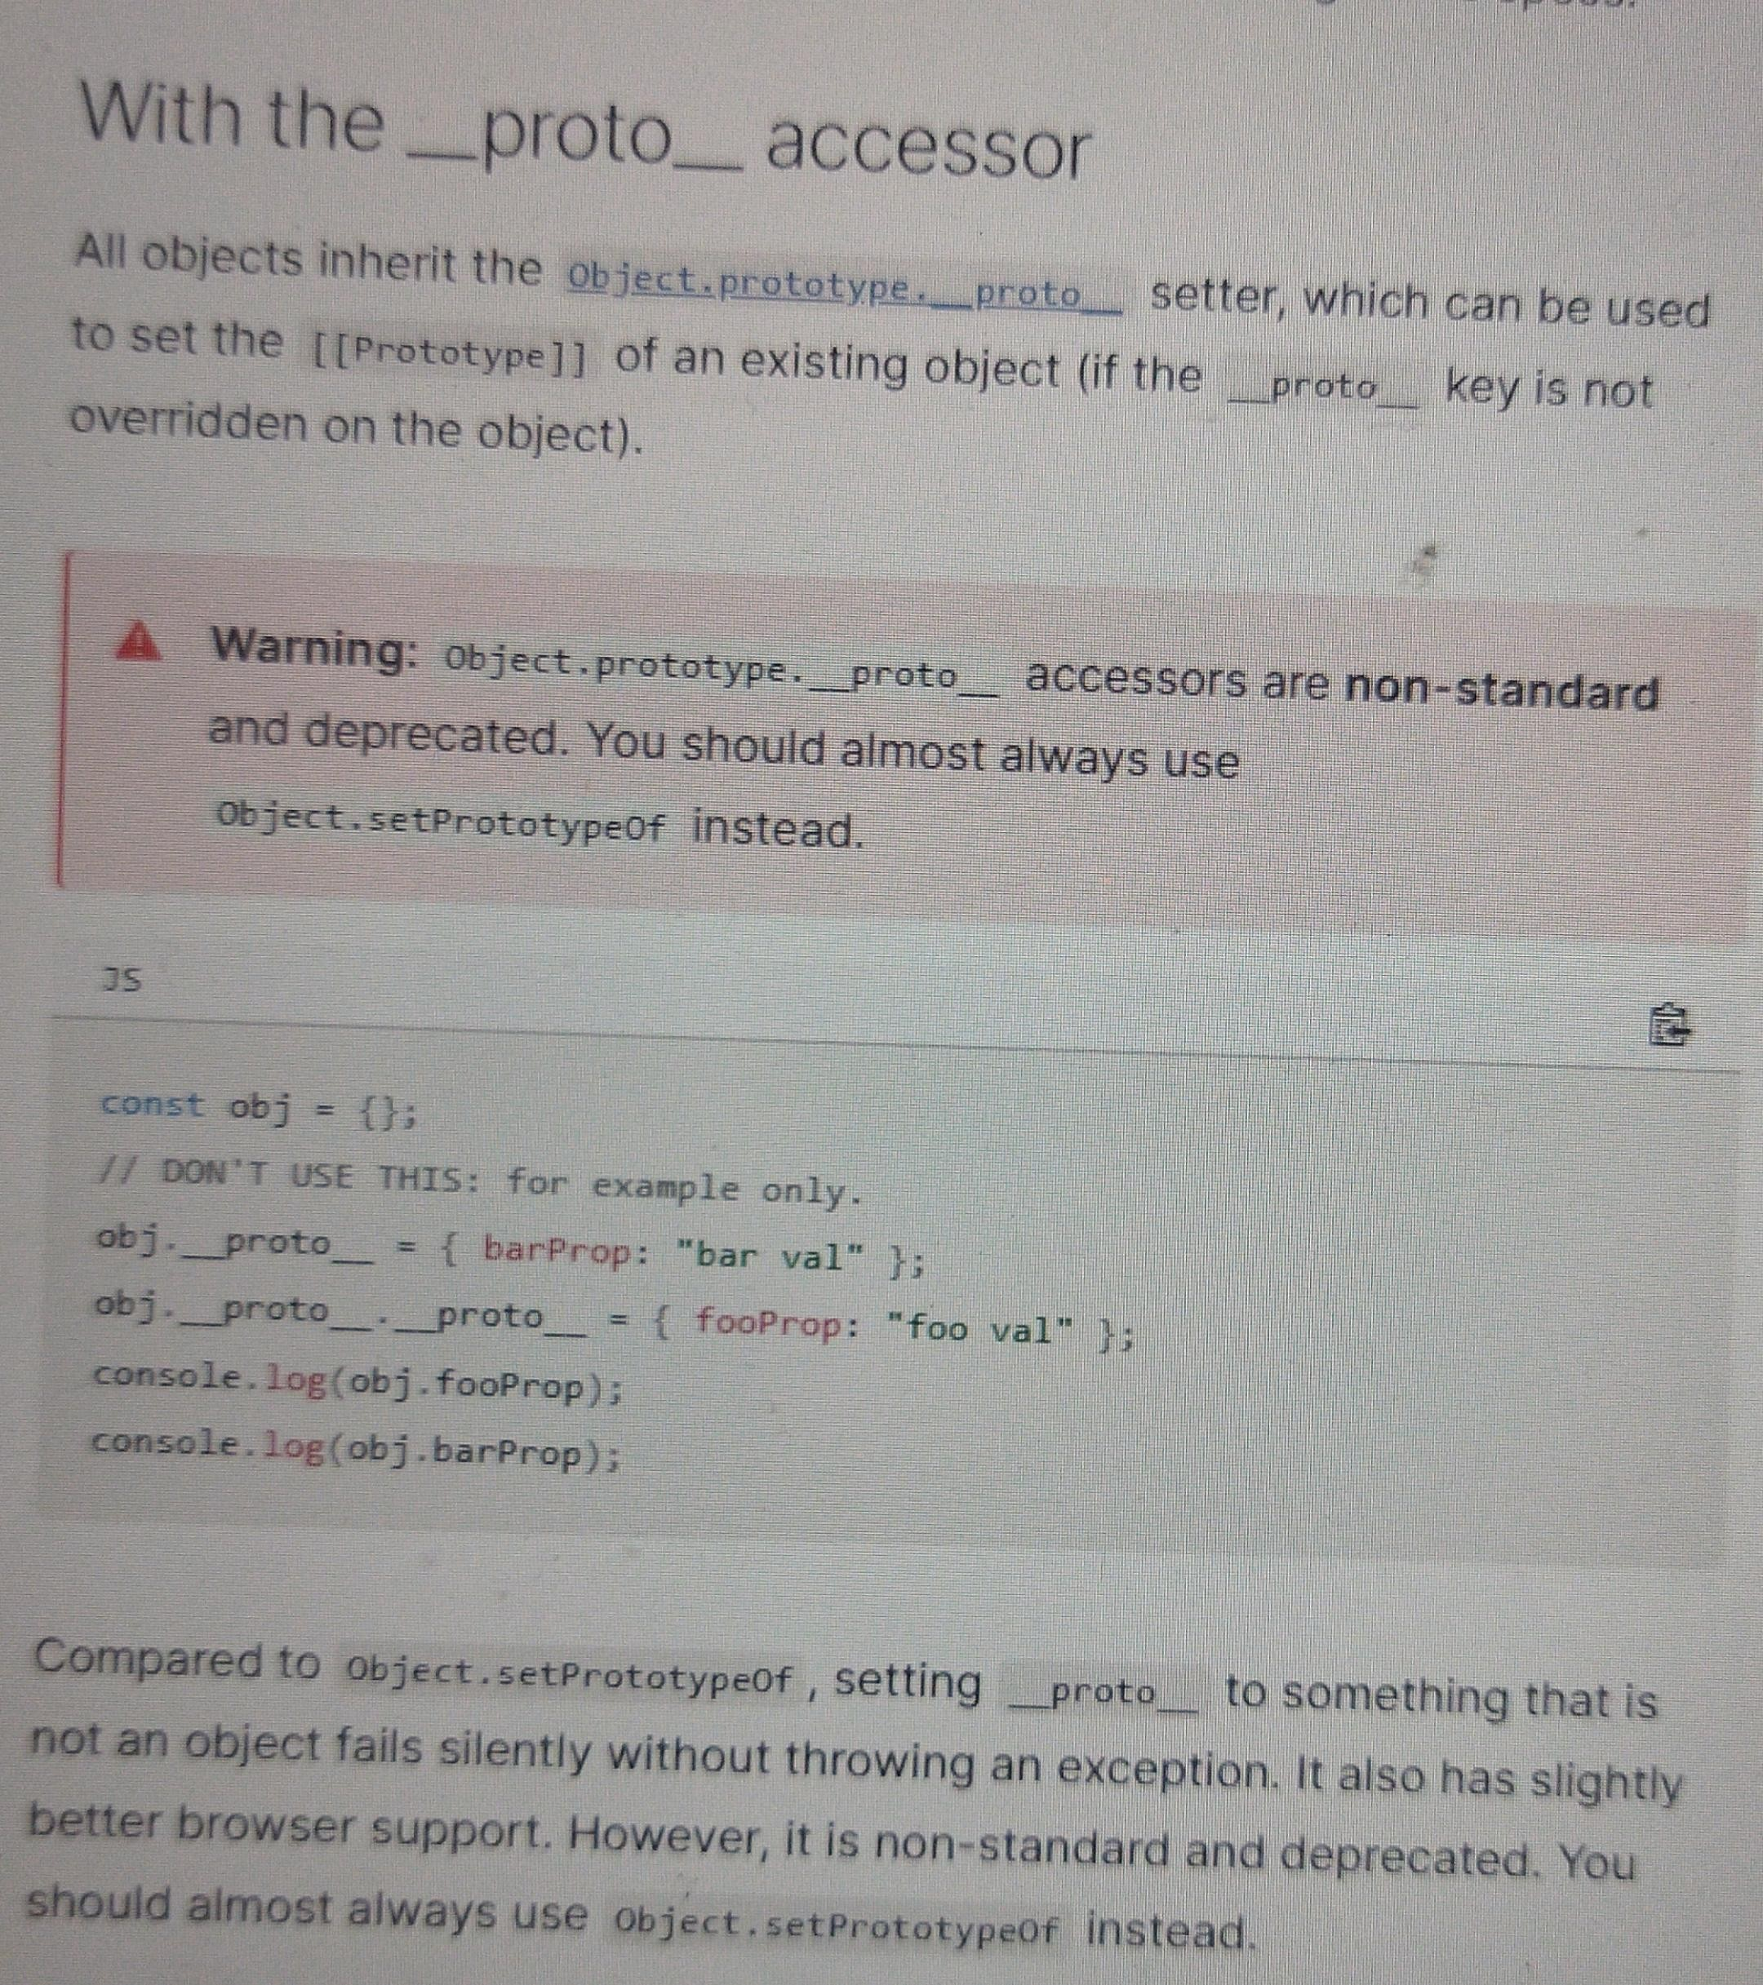

#### Explain stack, queue and event loop in JS with example

Refer from 12:15 to 16:13

<https://www.youtube.com/watch?v=8aGhZQkoFbQ>

## What is ECMAScript

## What is JavaScript

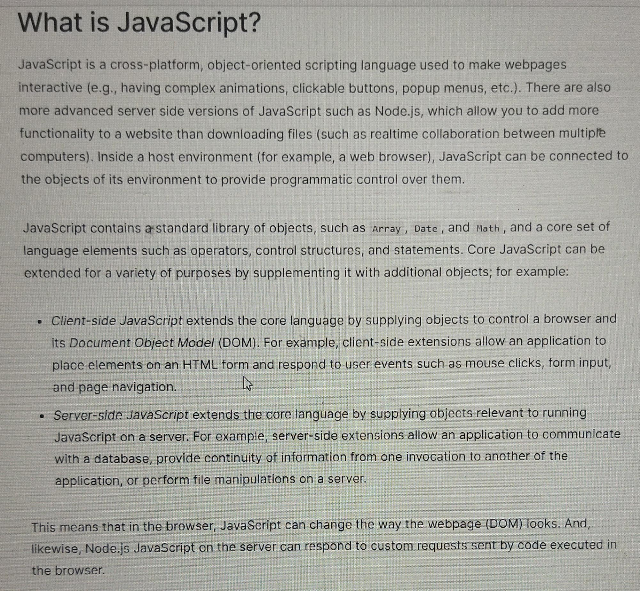

# All-CSS

## Explain Box Model?

Everything in CSS has a box around it, and understanding these boxes is key to being able to create more complex layouts with CSS, or to align items with other items.

[**Block boxes & inline boxes**](https://developer.mozilla.org/en-US/docs/Learn/CSS/Building_blocks/The_box_model#block_and_inline_boxes)

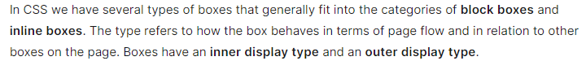

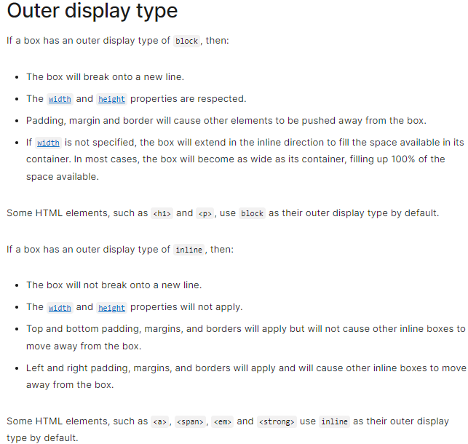

## Explain Box Model?

## Explain box-sizing property?

## Explain difference between border box & content box?

## Explain useState & useReducer hooks in React?

## Explain redux-toolkit!

## What is the difference between

## “display: none” & “display: hidden”?

## Explain difference between border-box & content-box?

## Explain useState, useReducer & Redux toolkit?

## 3 ways of styling a HTML document

### An external stylesheet

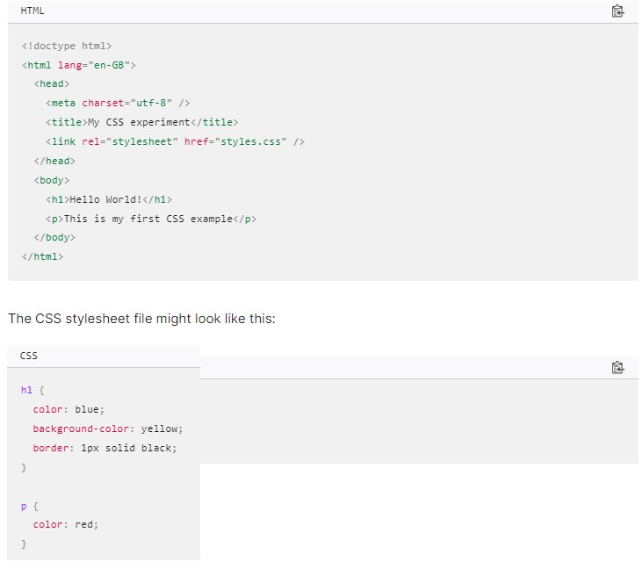

### An internal stylesheet



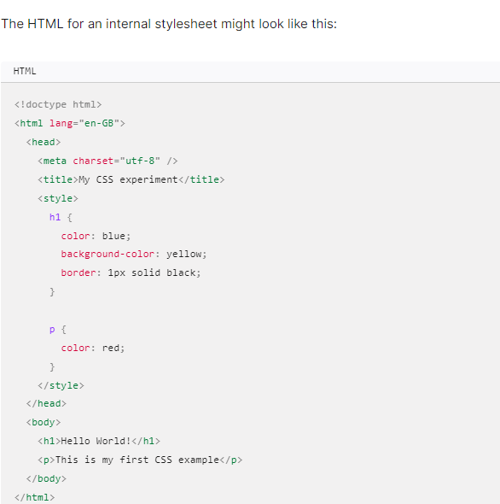

#### Practical Use case?

In some circumstances, internal stylesheets can be useful. For example, perhaps you're working with a content management system where you are blocked from modifying external CSS files.

### Inline styles

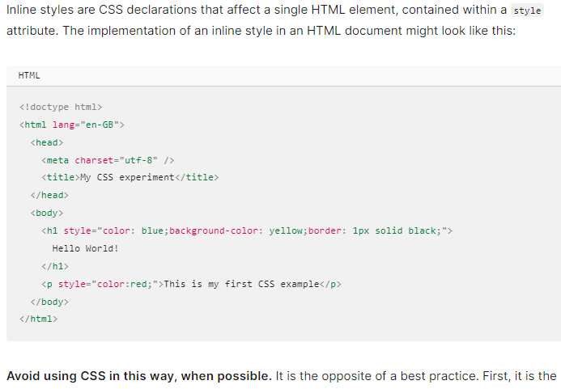

#### Practical Use Case?

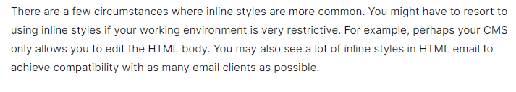

## What is cascade and specificity in CSS?

The CSS language has rules to control which selector is stronger in the event of a conflict.

These rules are called **cascade** and **specificity**.

### Explain Cascade rule in CSS?

Later styles replace conflicting styles that appear earlier in the stylesheet.

This is the **cascade** rule.

Consider:

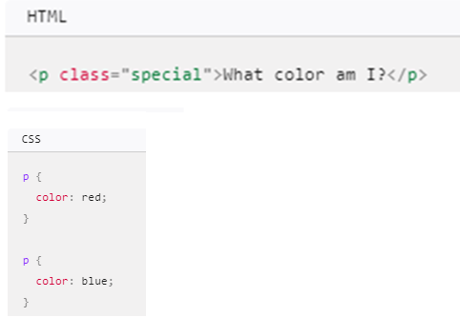

Output: blue colored text

Which CSS rule will apply? > Both

Which selector prevails? > Blue > Last in document (cascade rule)

### Explain Specificity rule in CSS?

Consider

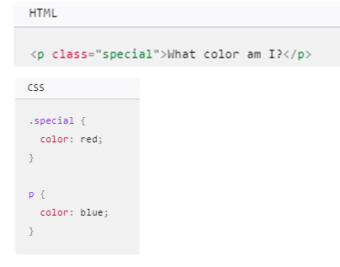

Output: Red colored text

A class is rated as being more specific, as in having more **specificity** than the element selector, so it cancels the other conflicting style declaration.

## What if an invalid CSS property &/or value is given?

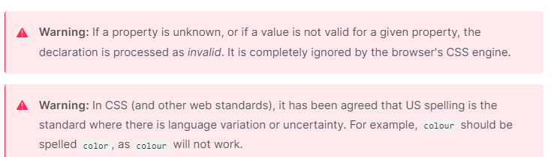

## Can functions be CSS values?

Yes,

### calc()

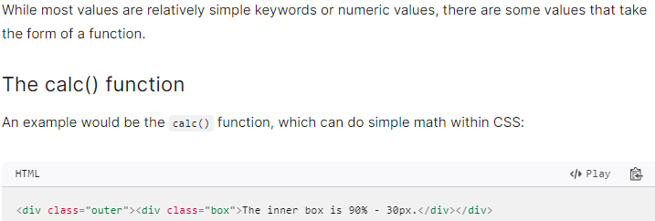

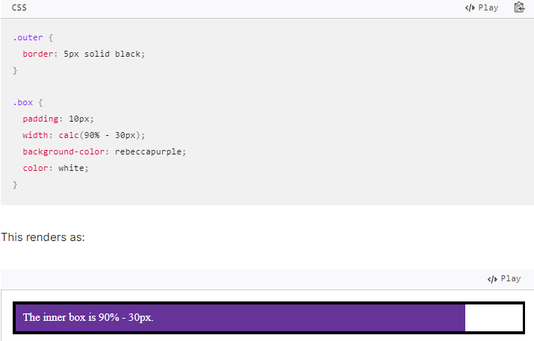

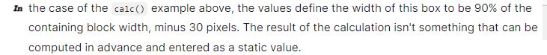

### transform()

<https://developer.mozilla.org/en-US/docs/Web/CSS/transform>

### color()

[https://developer.mozilla.org/en-US/docs/Web/CSS/color](https://developer.mozilla.org/en-US/docs/Web/CSS/color%20)

### background-image()

[https://developer.mozilla.org/en-US/docs/Web/CSS/ background-image](https://developer.mozilla.org/en-US/docs/Web/CSS/color%20)

## What’s at-rules in CSS?

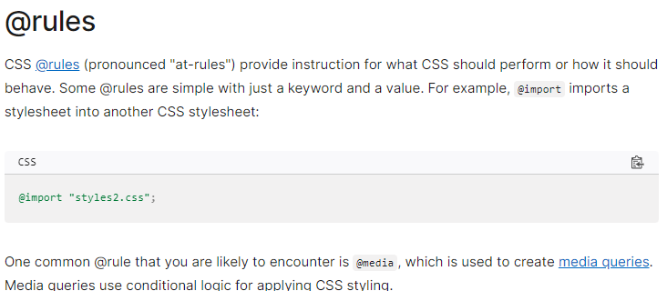

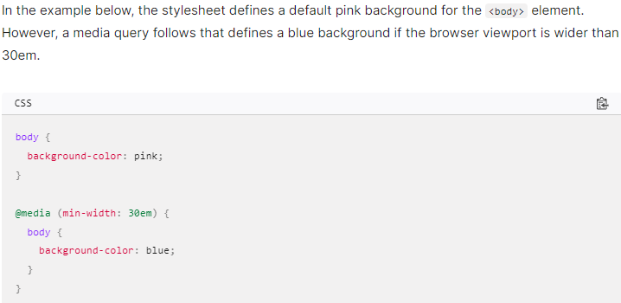

## What are media queries?



<https://developer.mozilla.org/en-US/docs/Web/CSS/CSS_media_queries>

## What are different types of selectors?

1. Type

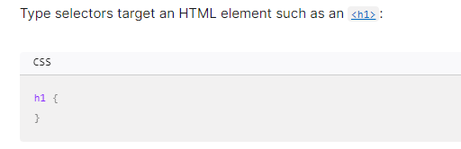

1. Class

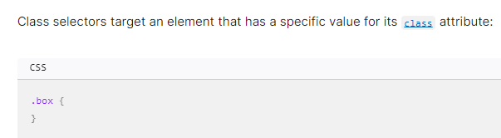

1. ID

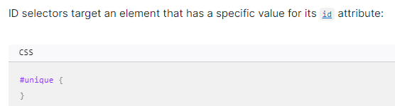

1. Attribute selectors

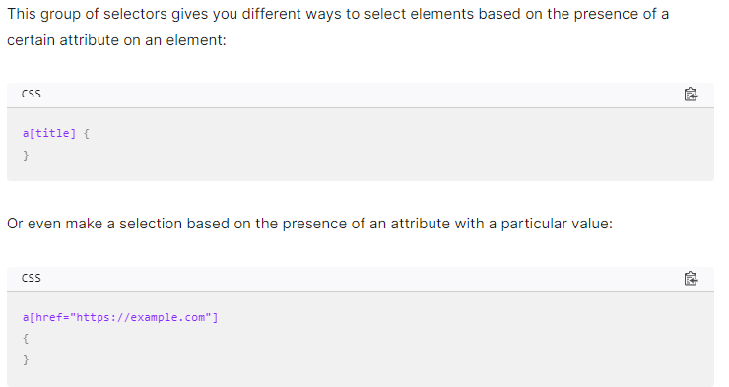

1. Pseudo-classes and pseudo-elements

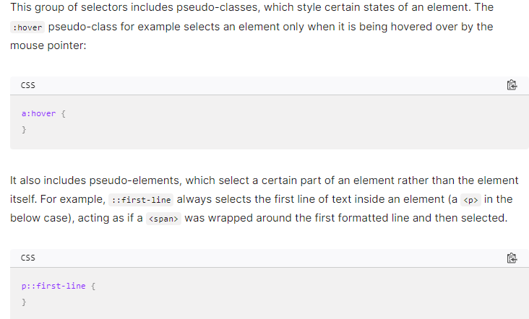

1. Combinators

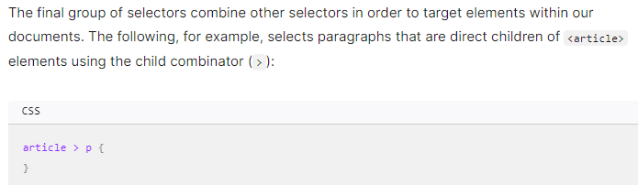

## To-do

Combinators & Selectors

<https://developer.mozilla.org/en-US/docs/Web/CSS/CSS_selectors>

### How CSS works?

<https://developer.mozilla.org/en-US/docs/Learn/CSS/First_steps/How_CSS_works>

# All-Tours-Planning

## Chandrakhani Pass

Bias

Bhirgu

### All Addresses & Locations

#### Ambala City UBC Railway Station

<https://maps.app.goo.gl/YioxvQZa7ufv96q16>

#### Beas Bridge Manali

<https://maps.app.goo.gl/Vbaqs7VJVS6iUXra7>

OR

<https://goo.gl/maps/nnyzykMkir853fhN8>

#### Indiahikes Jungle Line Campus

<https://maps.app.goo.gl/YheFv5hXjQjY2WCs6>

### Itinerary

#### Day -3 = 04-07-2024

Reach to Mumbai if Friday work from home possible

#### Day -2 = 05-07-2024

Start from CSMT at 23:30:00 CSMT ASR Express

#### Day -1 = 06-07-2024

Journey in train

#### Day 0 = 07-07-2024

Get down at 08:09:00 - Ambala City.

Reach Chandigarh

##### Ambala City to Chandigarh Bus Stand = 45 km | 1 hour 10 mins

<https://maps.app.goo.gl/DEzPdB4bSEmdAShb7>

##### Chandigarh Bus Stand to Manali Bus Stand 275 km | 6 hours

##### Manali Bus Stand to Beas Bridge 500m | 10 mins

##### Ambala City to Beas Bridge Manali 320 km | 7 hours

#### Day 1 = 08-07-2024

**Reach the Indiahikes Jungle Line Campus at Manali**

**Reporting Time:**3 pm **|**

**Location:** [Beas Bridge, Manali](https://goo.gl/maps/nnyzykMkir853fhN8)

Pick-up will be arranged from [Beas Bridge, Manali](https://goo.gl/maps/nnyzykMkir853fhN8) to Indiahikes Jungle Line Campus at 3 pm. It will cost Rs 1,000 per vehicle (5-6 seaters) and has to be shared by trekkers. You will be staying at our campus on this day. The vehicle will be non-A/C.

#### Day 2= 09-07-2024

#### Day 3= 10-07-2024

#### Day 4= 11-07-2024

#### Day 5= 12-07-2024

**Trek from Naya Tapru to Rumsu.**

**Drive back to Indiahikes Jungle Line Campus at Manali.**

**We will reach Manali by 8PM.**

#### Day 6= 13-07-2024

Board Paschim Express from Chandigarh to Mumbai Central

At 12:20 PM

#### Day 7= 14-07-2024

#### Queries

##### Ambala City UBC to Manali Direct Bus commute options?

##### Ambala City UBC to Chandigarh Bus commute options?

##### Chandigarh to Manali Buses Stand commute options?

##### From Manali Bus Stand do we have overnight buses to Chandigarh & Last Bus timing?

##### Trek last day is 12th, So will we reach Chandigarh before 8AM on 13th?